Key printed / expected outputs from the Solution notebook
1. Reproducibility
R
set.seed(42)sample(1:10, 5)# → 10 9 3 6 4 (reproducible)
2. Generative models
R
sample(1:30, 5, replace = TRUE) # discrete placesrunif(5) # continuous uniformrnorm(5, mean = 15, sd = 5) # normal-like places
3–4. Single-trial + Monte-Carlo matrix
R
one_race <- function(n_runners = 30, friends = c("Megan","Janet","Tina")) { places <- sample(1:n_runners, length(friends), replace = TRUE) names(places) <- friends places}place_mat <- t(replicate(1000, one_race()))# head(place_mat) shows 1000 × 3 matrix of simulated places
5. Summaries (n_runners = 30)
text
Expected place (colMeans) ≈ 15.5 for each friendP(place ≤ 10) ≈ 0.33 for each friendP(all three ≤ 10) ≈ 0.037
7. Sensitivity to field size
text
n=15 n=30 n=60 n=100Megan 0.67 0.33 0.17 0.10Janet 0.67 0.33 0.17 0.10Tina 0.67 0.33 0.17 0.10# (approx; declines roughly as 10 / n_runners)
Alternate — Bootstrap 95 % CI for mean place
R
boot_means <- replicate(2000, mean(sample(megan_places, replace = TRUE)))quantile(boot_means, c(0.025, 0.975))
Interactive section — change n_runners, n_sims, success_at and re-run to see how expected places and success probabilities shift.
More practice highlights
- Truncated-normal generative model changes the shape of the place distribution.
- Joint probability that all three finish in the top half.
- Distribution of the best place among the three friends.

Example simulation plots
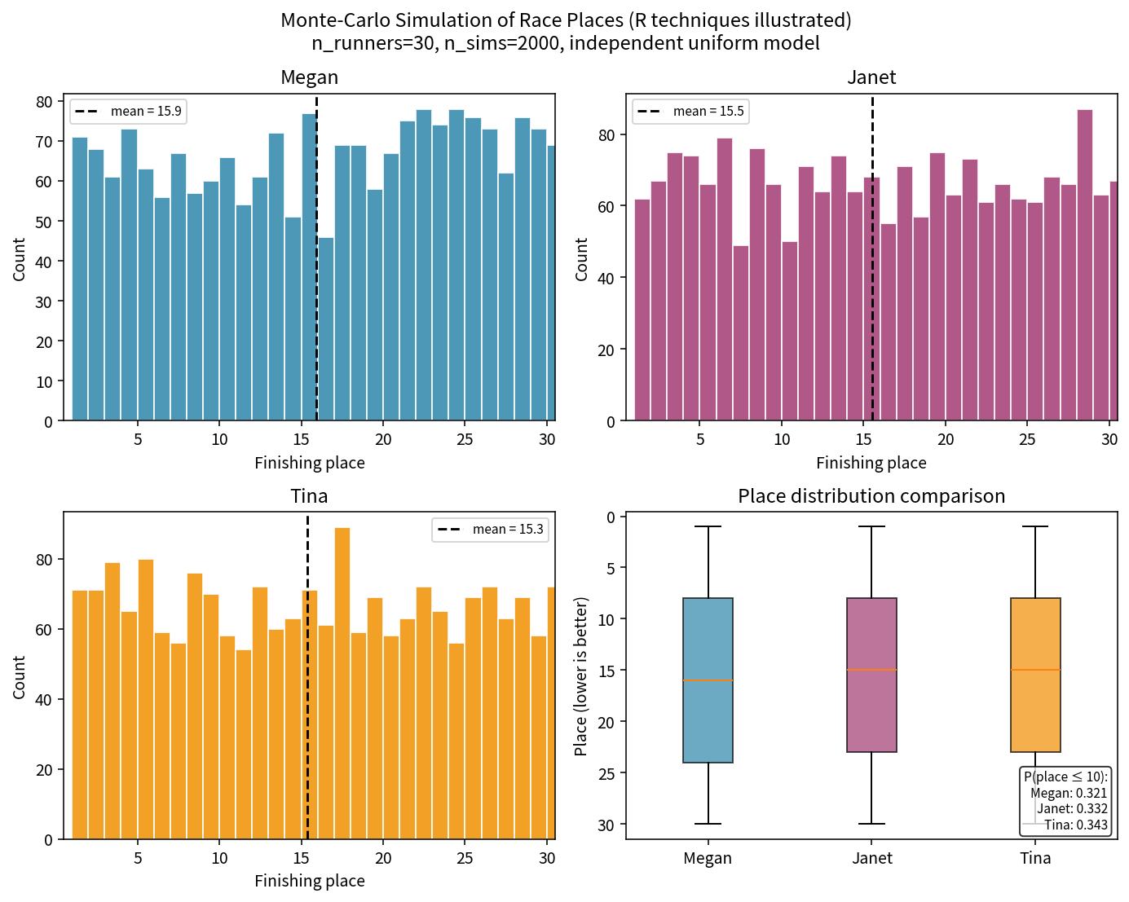

1-Page Summary Report structure
- Problem Statement — quantifying uncertainty in places / joint events when analytic formulas are awkward
- Solution Strategy — seed → single-trial function → replicate/sapply → summarize → visualize → sensitivity → bootstrap
- Solution — table of key results + embedded flowchart & plots
- Key Takeaways — core Monte-Carlo pattern, empirical probabilities, free sensitivity analysis, bootstrap for intervals, extensibility to power / rare-event / randomization tests
Download the zip for the complete package, or open the Practice Skeleton to work through the techniques yourself and compare with the Solution.

